Abstraction: Hiding actual implementation and showcasing the feature.

Note: method body (or) method definition both are same.

Note: normal method is also called as concrete method.

1. In java we can have methods without implementation (without body) but those methods must be declared abstract. It will have only method signature. Abstract methods are written by using abstract keyword before the method.
2. In a class if one method is abstract, the class should also be abstract.
3. You can have abstract class without abstract methods.
4. Abstract class can have all concrete methods, but creation of object is not possible.
5. Variables cannot be abstract.
6. Abstract class can have normal concrete method also. abstract class can have all methods as abstract (then it is said to have 100% abstract), combination of abstract and concrete method (then it is said to have below 100% abstract)
7. Whenever you extend abstract class, then it is mandatory to give body of abstract method in child class (or) make child class as abstract.
8. We can create reference of abstract class (loose coupling).
9. We cannot create object of abstract class (tight coupling). (since there is no-body for abstract class, there is no need of creating the object).
10. Constructor cannot be abstract.
11. final access modifier cannot be applied to abstract class (because final access modifier will restrict the class to participate in inheritance, but abstract class must participate in inheritance to implement its abstract method code in child class)
12. abstract method cannot be final (because if a method is made final, it will participate in inheritance but overriding it in child class is not possible. if we make abstract method as final, the abstract method cannot have a body, and the final will not allow to override, so using final for abstract method is illegal)
13. we can have constructor in abstract class.

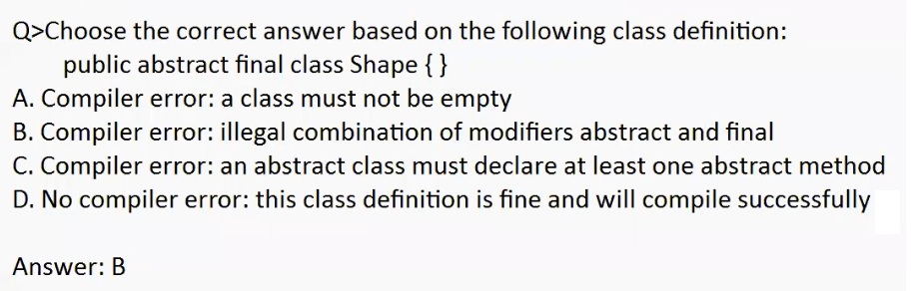

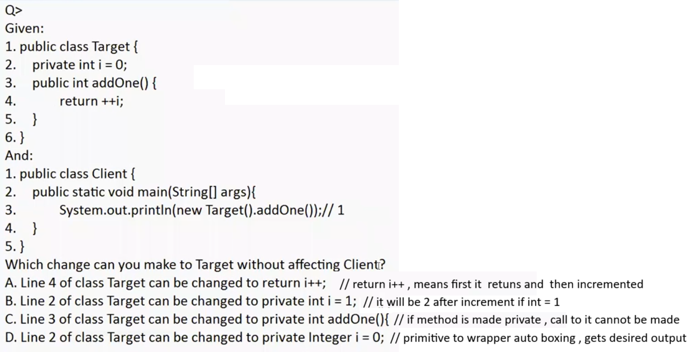

If a variable is made private outside of the class we cannot access it. Here the private variable is accessed only in the class it is declared so no problem. And we can access that method since addOne() is public

